Devendra Kulkarni
Contact: +91-9049578167/9420388386 E-Mail: kulkarni.devendra13@gmail.com
A-46, Vasant Vihar Society, Near Lokmat Office,
Sinhagad Road, Pune-411041.

An MBA, with more than 3 years of experience in General Ledger, Bank Reconciliation, GL Reconciliation, Vendor Payment, Salary Calculation, Intercompany Settlements, Intercompany Transactions etc.
Presently working with Wipro BPS Ltd as a Senior Officer.

PROFILE SUMMARY

- Completed MBA, B.Com (Costing) from Pune University with experience of over 3 years.
- Presently working with Wipro BPS Ltd., Pune as Senior Officer (Finance & Accounts).

EMPLOYMENT DETAILS

Since Jan’15 to till date: Wipro BPS Ltd., as a Senior Officer
Reporting to the Assistant Manager – India
Highlights
- Working in Pilot batch process for setup a new business in the Wipro.
- Working with General Ledger Accounting (R2R) team for month end closing on SAP based system & reporting to Singapore Client.
- Basically working on SAP (FICO 7.0) with major transaction codes(FBL5N,FBL3N, FBL1N,ZFICO033,FB08, FB03,FB02, F-28, F-53,F-03,F-63,FBRA)
- Preparing schedules for accrual income & prepaid expenses and creating the journal for the same posting into the SAP
- Month end activities – AIP, Payroll, GL clearing, Vendor clearing, Intercompany Settlements, Bank Reconciliation, Petty cash, Reversals, Bank Payments, Incoming & Outgoing Fund Entries, Intercompany transactions, Forex Revaluations, Commission calculations.
- Preparing Intercompany invoices for processing to Indirect AP team & looking out payment entries.
- Preparing reconciliation for GL accounts, successfully diminishing the open item of AP with taking an initiative & follow up with the respective market.
- Successfully completed Year-end closing in 2015, 2016 & 2017.
- Preparing SLA report after the closing & reporting to the client.
- Working on Intercompany Settlements activities regarding Forex transactions.

From 24th July’14 to 2nd Jan 15: Mphasis Ltd., as a Tr. Transtn Procg-cplx Proc. (TPO)
Reporting to the Team Leader – India
Highlights
- Process work is Quality Checker of the Legal Agreements from the year 1971 to 2015
- Work is read whole Authenticated agreements then Auditing the data collected by authenticators in the software & create Checker Report of the respective data for preparing the report & send it to the Client.

IT SKILLS

- Microsoft Packages : Microsoft Office XP (Word, PowerPoint, Access and Excel)
Operating Systems : MS Windows 98, XP And Windows 2007 & 2010.
- Certification : MCP Certification Exam. (70-270 & 70-290)
- System Handled : SAP: FI Module, Tally 9.0, typing 30WPM Exam passed

EDUCATION

- ICWA Pursuing.
- MBA (Finance) from Pune in 2014 with 61%
- B.Com (Costing) from Pune University, in 2011 with 54%
- HSC from Maharashtra Board 2007 with 57%
- SSC from Maharashtra Board in 2005 with 64%

Other Activity

- Participated in Mindscape Industrial Inter-College event of Audyogik Shikshan Mandal.
- Attended the Youth Seminar Green Growth-Preparing youth for sustainable growth.

PERSONAL DETAILS

- Date of Birth: 13th Oct, 1989
- Marital Status: Married
- Hobbies: Playing Cricket, Listening Music.
- Passport No: N8186974
- Address: A-46, Vasant Vihar Society, Near Lokmat Office, Dhayari Phata, Pune-411041
- Languages Known: English, Hindi and Marathi

DECLARTION
I, Mr. Devendra D. Kulkarni declare that all the information is true to the best of my knowledge.
Thanking You.

Yours Sincerely
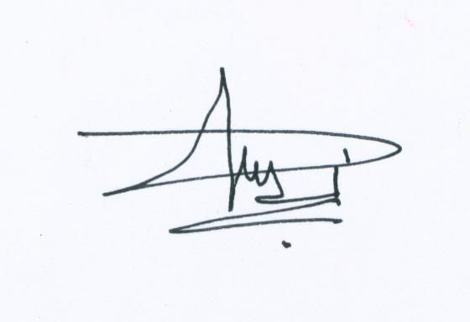
Devendra D. Kulkarni.

